# Introduction

The following are taken from studying Meeus, Jean Astronomical Algorithms second edition 1998, ISBN 0-943396-61-1. This document is part of my Astronomy project where I aim to calculate the Suns position in a command line utility using C++.

In the introduction, Meeus says:

...in order to create a program for the calculation of the altitude of the Sun for a given time on a given date at a given place, one must first convert the date and time to Julian Day (Chapter 7), then calculate the Sun’s longitude for that instant (Chapter 25), its right ascension and declination (Chapter 13), the sidereal time (Chapter 12) and finally the required altitude of the Sun (Chapter 13).

Following these instruction I will create a software model that gives me the Sun’s position for a given time, on a given date at a given place.

Another, in my opinion, good source for astronomical calculations, [is this website](https://www.aa.quae.nl/en/colofon.html), maintained by Dr. Louis Strous.

I will use these, and more, during my Astronomy project.

Table of Contents

[Introduction 1](#__RefHeading___Toc353_709782013)

[Properties of the Sun 3](#__RefHeading___Toc355_709782013)

[The Sun’s orbit 3](#__RefHeading___Toc357_709782013)

[Parameters to compute the location of the Sun 4](#__RefHeading___Toc359_709782013)

[What do we need? 4](#__RefHeading___Toc123_2634702301)

[Ecliptic, equator and the equinoxes 4](#__RefHeading___Toc361_709782013)

[Ecliptic 4](#__RefHeading___Toc125_2634702301)

# Properties of the Sun

In all simplicity, the Earth orbits the Sun some 23° degree tilted, as seen in , giving us the seasons, as seen in . In order to calculate where the Sun is on the sky, seen from a place on Earth’s surface, we need to know a thing or two about the Sun’s apparent movement.

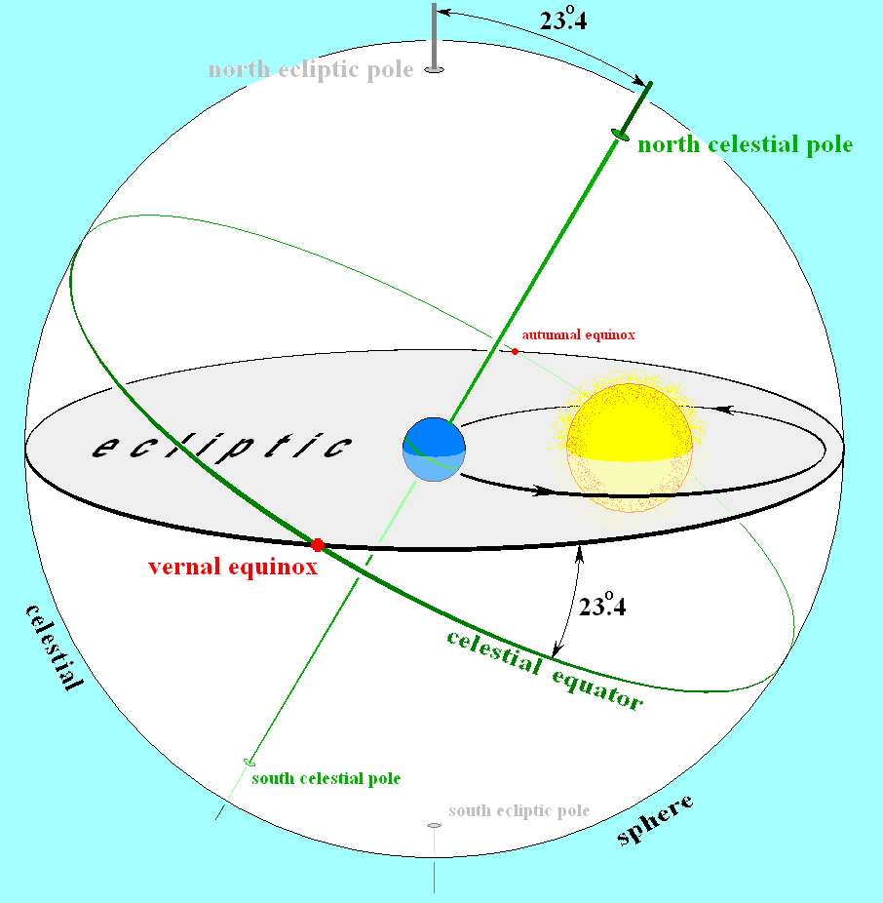

Figure 1: Sun-Earth system, source: [Wikipedia](https://en.wikipedia.org/wiki/Ecliptic" \l "/media/File:Earths_orbit_and_ecliptic.PNG)

As it turns out, we have a number of ways to describe where the Sun is, at any given time and place. In the next sections I will try to give a description of these parameters, and how we calculate them.

## The Sun’s orbit

[According to NASA](https://solarsystem.nasa.gov/solar-system/sun/in-depth/), the Sun orbits the center of our galaxy, taking about 230 million years to complete one roundtrip. For all our intensive purposes, we treat the Sun as a stationary object. When we later talk about the Sun’s movement, we mean the *apparent* movement. We’ll use these terms interchangeably.

## Parameters to compute the location of the Sun

We differ between the parameters that describe the Sun’s location in space, and those describing the Sun’s position on the sky as seen from Earth. We will first discuss the parameters that describe the Sun’s position in space.

## What do we need?

[According to Dr. Louis Strous](https://www.aa.quae.nl/en/reken/zonpositie.html), the position of the Sun on the sky, seen from a planet such as Earth, is determined by four thing:

1. The time
2. The planets motion in it’s orbit around the Sun.
3. The angle between the rotational axis of the planet and the plane of the planet’s orbit.
4. The location of the observer on the planet.

We also need a system of references, and as we will see, the different parameters have different systems of reference.

As we go along, we will describe the different elements giving examples on how to calculate them.

## Ecliptic, equator and the equinoxes

Trying to calculate the position of the Sun, we must first define a system of reference.

### Ecliptic

As the Earth orbit the Sun, it draws out the ecliptic plane, as seen in Figure 2. From a viewer on Earth it seems like the Sun travels around the Earth, but it actually is the oher way around. However, it is convenient to think of it as the Sun orbits the Earth. Me, I think it’s easier to visualise it that way.

Figure 2: The ecliptic is formed by the Earth's orbit around the Sun.

### Calculate sunrise and sunset times

Character Displayed Alt Code

Alpha α Alt 224

Beta β Alt 225